**List of Key Electronic Parts for the two mic impedance tube**

1. Speaker Amplifier

XH-M542 TDA3116D2 digital power amplifier board 100W high power mono audio amplifier module

[Ali Express](https://www.aliexpress.com/item/1005006018931672.html?spm=a2g0o.productlist.main.3.561178b4yOccfW&algo_pvid=0bfe1622-ea96-4c9d-96ab-1fa7b6d497c6&aem_p4p_detail=202310122132553925057610369280003593242&algo_exp_id=0bfe1622-ea96-4c9d-96ab-1fa7b6d497c6-1&pdp_npi=4%40dis%21NZD%212.80%212.8%21%21%2111.88%21%21%402101eab016971715756937666e203f%2112000035348202664%21sea%21NZ%210%21AB&curPageLogUid=KadSaey5YcUb&search_p4p_id=202310122132553925057610369280003593242_2)

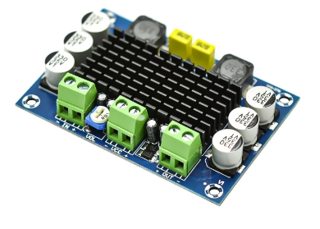

1. Microphone and Amp (Two Needed)

KY-037 High Sensitivity Sound Microphone Sensor Detection Module For Arduino AVR PIC

[Ali Express](https://www.aliexpress.com/item/1005003946947767.html?spm=a2g0o.productlist.main.1.337c663dow2HXL&algo_pvid=4cd3f509-8af6-489f-906d-5c8c3f49cd2c&aem_p4p_detail=202310122135061764216688948590003446267&algo_exp_id=4cd3f509-8af6-489f-906d-5c8c3f49cd2c-0&pdp_npi=4%40dis%21NZD%210.72%210.72%21%21%210.42%21%21%402103011016971717060233043e9c92%2112000027536853441%21sea%21NZ%210%21AB&curPageLogUid=v7cUxDZNbMSx&search_p4p_id=202310122135061764216688948590003446267_1)

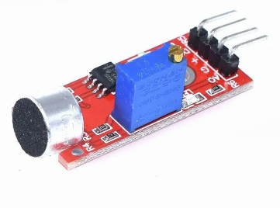

1. Sound Card

KEBIDU USB 2.0 Sound Card Audio Card CM6206 Chipset 6 Channel 5.1 Sound Card SPDIF Controller Audio Card for PC Laptop Computer

[Ali Express](https://www.aliexpress.com/item/4000688765920.html?spm=a2g0o.productlist.main.5.36823e11xwkCv7&algo_pvid=e4cb099b-5d5a-4db9-a3c3-7dd3a55b523d&algo_exp_id=e4cb099b-5d5a-4db9-a3c3-7dd3a55b523d-2&pdp_npi=4%40dis%21NZD%2128.11%2117.05%21%21%2116.32%21%21%402103010e16971718010238700e8833%2110000006033963872%21sea%21NZ%210%21AB&curPageLogUid=LW0rwwTKJ0GA)

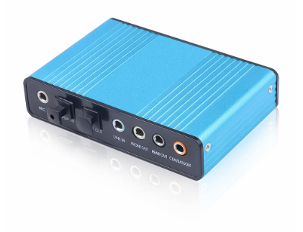

Circuit Schematic:

